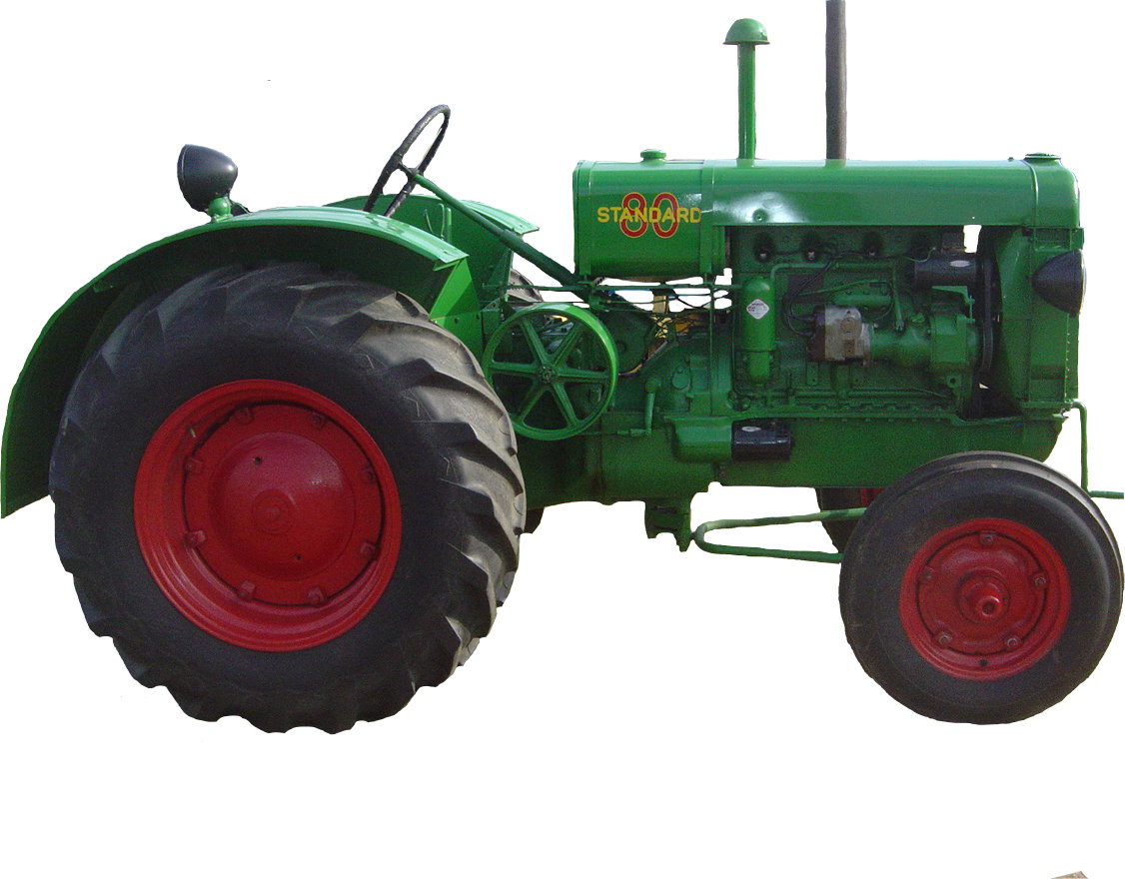

F O O T H I L L S

F O O T H I L L S

ANTIQUE POWER ASSOCIATION
ESTABLISHED 2003
June 2015
Dear Members,
Wow! What a show! Great weather, great crowd, but that is we prayed for, right? It looked like everyone had a great time. As always, a couple things came to light that need to be worked on for next year, but that is normal, and, if we did not care about doing the best we can do, we would not be concerned about them. But, we do care, and if we can do anything to correct it we will.

--- --- --- From our June Meeting --- --- ---

- About a week after the show, member Randy Setzer lost his battle with cancer. We pray that our heavenly Father will continue to comfort the Setzer family.

- Heavenly Father, in the glorious and precious name of Jesus Christ our Lord, our intercessor, our mediator – the one you put in the position of all power and authority at your right hand, we come to you knowing that you are able, willing, and eager to provide all we need and that because we know you to be faithful to your promises and to your holy word. We place these, our brothers and sisters, into your caring and capable hands to provide them peace of mind and heart, healing of body and soul, and spiritual guidance and strength so they can be in this world what you would have them be. Amen.

  - Kelly Blanton
  - Glenn & Dot Hawn
  - Butch Minyard
  - Nancy Edgar
  - Denelda Reese
  - Gerry Stewart
  - Sheldon Smith
  - Rev. Bobby Langston
  - Allen Everdyke
  - Lorna Sheets
  - Charles Huffman
  - Steve Hefner
  - Penny Hodges
  - Justin Beach
  - Wade Hefner
  - Charles Elmore
  - Norris Turner
  - Kristie Isenhour
  - Don Johnson
  - Stewart (Ranny) Frye
  - Ned Story
  - Carl Porter
  - Jane Abernathy
  - Terry Martin
  - Jim Davis
  - Eugene Hartley

- Both the show committee and the members present at the June meeting had very positive feedback on the show. As always we want to keep an eye out for that which was right as well as the things we need to work on so we can work on making the 2016 show even better than this year’s. No decisions or actions have yet been made on any of these – that will be done in the coming months. Some of the suggestions are:

  - Whether or not to keep Sunday as an official show day.
  - Making more efficient use of the display area - fill in the many open spaces by:
    - Moving craft vendors out of the exhibit hall.
    - Establishing forfeiture requirements on unused reserve spaces.

  - Better organization of the parade of power, demonstrations, and parking lot traffic flow.

  - Placing a couple tents with chairs around the midway for rest/cool-off stations.

  - Using armbands for exhibitors, vendors, etc. to help clarify who pays to enter and who does not.

- The store building was a very popular aspect of the show and it will only become more so as time goes on and more display items are added.

  - We are planning to have a security system installed because of the number of valuable items already there.

  - During the May show and during the fair, when the doors are open, we need to have one person who would take on the responsibility of coordinating stewardship of the store. This would simply be getting volunteers (or designees) to spend a couple hours each in the building to look over things while the public is coming in and out. If you are willing to help, please contact Kevin Black.

- The first Swap Meet planning meeting will be on July 16.

--- --- --- UP-COMING EVENTS --- --- ---

June 12-13 Shelby Carolina Threshers Reunion
June 13 Maiden Catawba Valley Harvesters Show
Jun 30-Jul 4 Denton Southeast Old Threshers Reunion
July 2 Sig’s July monthly meeting
July 16 Sig’s Swap Meet planning meeting
July 23-25 Boone High Country Crank-up
Aug 6 Sig’s August monthly meeting
Aug 7-8 Turnersburg Spokes & Cleats Show
Aug 20 Newton Old Soldiers Reunion parade
Aug 26-29 Portland IN Tri-State Gas Engine & Tractor Show
Sept 3 Sig’s September monthly meeting
Sept 4-6 Dacusville SC Dacusville Farm Show
Sept 10-12 Bellwood Bellwood Antique Tractor & Engine Show
Sept 19 Newton FAPA Swapmeet
Oct 1 Sig’s October monthly meeting

--- --- --- THE CLASSIFIEDS --- --- ---

Is there anything you would like to sell or are you looking for something special? List it here.
(Item listings will run for 3 months before expiring. Let us know when an item is sold or bought.)

FOR SALE

Camping spot available at Denton during Southeast Old Tresher’s Reunion, Kermit Nash 828-459-9616 (15-03).

JD 210 Lawn tractor, mower & snow blade, $600, Carroll Hilliard, 828-241-4061 (15-03).

1948 Ford 8N, show ready, $6000, (one of first tractors displayed at FAPA), Carroll Hilliard, 828-241-4061 (15-03).

1951 Super A, GC, runs VG, 80% rubber, +cultivators, Alice Parris, 704-462-2010 (15-05).

WANTED

Meadows grist mill, 8” cast iron, Ray Abernathy, 704-735-1224 (15-03).

Farmall M /460 rear wheel weights, B.J. Moretz, 828-292 -6387 (15-03).’

☺ ☺ !!!!! HAPPY BIRTHDAY !!!!! ☺ ☺

June birthdays

1 – Mark Cunningha
1 – Larry E. Davis
2 – Ned Story
4 – Charles McRee
5 – Butch McIntyre
6 – Ron Bachman
6 – Alton Reed
9 – Barry Matthews
9 – Danny Joe Little
10 – Roger Matlock
11 – Tony Sigmon
13 – Keith Schronce
14 – John Bumgarner
16 – Andy Parsons
17 – Michael Jarrett
21 – Michael McAlister
24 – Billy Herman
26 – Marcus Strickland
29 – Carroll Reed
30 – Willie Adams
30 – Kristie Biggar
30 – Robert Hindman
30 – Myron Yount

July birthdays

6 – Charles Bentley
9 – Tim Yelton
18 – Gwynn Wallace
19 – John VanHorn
21 – Larry Davis
23 – Carroll Hilliard
23 – Barry Poovey
28 – Brandon Sigmon
29 – Bill Lippincott
30 –John Stanton
31 – Charles Huffman

5851 St. Peter’s Ch. Rd. Conover, NC 28613
President: Kevin Black 828-464-1950 Vice Pres: Wilson Sigmon 828-256-2176
Treasurer: Kermit Nash 828-459-9616 Secretary: David Setzer 828-850-4943
Show Chair: Ned Story 828-464-6399 Asst.Show Chair: Teddy Hefner 828-310-5525
Asst. Secretary: Kevin Sigmon 828-256-2176
www.foothillsantique.com
--- --- --- a thought for Father’s Day --- --- ---

On a wall in the old milking barn on the farm where I grew up are words written by the unsure hand of a six-year-old. The pencil lines are faded, but they are still legible and the message they convey is clear. Even though the spelling is bad, the words clearly read: “Softly and tenderly Jesus is calling.” The young boy who wrote those words was me. The words were those I heard my father singing as he milked the cows. I cannot remember what I was thinking when I wrote on that wall, in fact I forgot about doing it. Nearly 30 years later (after my father had died), I found them again and only then was the message those words conveyed clear – a message that is more than the simple meaning of the words.
Our mothers carry us for nine months then, with pain and joy, bring us into this world so we can live life. We mature under their care and nurturing. Were it not for them, we would not have a life to live in this world.
But what of our fathers? Is their work done before our mother’s begins? Are they only the “male figure” or the disciplinarian in our families? The truth is, a father has a much greater responsibility toward his children than raising them to be good men and women. Like our mothers, our father’s responsibility is a God-given one: to raise his children in the nurture and admonition of the Lord. Yes, our mothers are to do that too, but it is the father who is the one primarily responsible before God.
What my father did for me in that milking parlor over fifty years ago set the stage for me to receive the “life of the ages” – eternal life. He did not sit me down and say: “now this is the way it is …” He simply lived his faith and it was that faith lived in the sight and hearing of a young boy that led me to believe and receive God’s gracious gift. But he could not nurture me fully in that new life – he simply did not know how, yet his work was not in vain. In time God graciously provided the nurturing I needed and in His grace I stand before you this day.
Many men, though they have sired offspring and are “good fathers,” are not true fathers because they neglect their God-given responsibility by not offering true life to their children. They must not love their children, at least, not as God would have them love. The result is generation after generation having no standards other than the selfishness of their own sinful hearts.
You who have children, are you performing this monumental, and vital task (to the best of your ability in the sight of God) fulfilling your God-given responsibility by giving eternal life to your children and nurturing that life, or have you abdicated it, leaving your children’s eternal life in the hands someone else? As long as there is breath in your lungs you can yet be a true father.
And you men who have no children, do not think for a moment that you get off scot free! You, in Christ, have the equally important responsibility to be an example of godly men to those who are fathers as well as to their children so they both can learn to keep their responsibilities.
I thank God that my physical father was also my spiritual father and I look forward to the day when I can once again shake his hand and finally thank him personally.

God bless you.
See you in July. Your Secretary,
David Setzer

